Experiment 3: Examination of a website to test the vulnerability of attacks. – DVWA setup & SQLi
Aim:
To examine and setup DVWA website to test the vulnerability of attacks and to perform SQL injection attack
Installing DVWA:
open kali linux
open the terminal
enter the command
cd /var/www/html
open the firefox browser and type dvwa github
click the link and copy the url and paste in terminal
sudo git clone https://github.com/digininja/DVWA
give command----> ls
check the folder dvwa
mv dvwa DVWA
ls
cd DVWA
cd config
check the folder config.inc.php.dist
sudo cp config.inc.php.dist config.inc.php
ls
cat config.inc.php
sudo nano config.inc.php
change db user===user
p@ssword ==pass------->chage
cat config.inc.php
check it is change or not
sudo service mysql start
sudo mysql -u root -p
create user dvwa;
create user dvwa@localhost identified by 'p@ssw0rd';
grant all on dvwa.* to dvwa@localhost;
flush privileges;
exit------------- get bye... message
sudo service apache2 start
http://localhost/DVWA or http://127.0.0.1/DVWA/login.php
user name::admin
password::password
----if any one getting the problem or accessing the page
please follow the steps
cd --enter
cd /etc
cd php
cd 8.1
cd apache2.....................or...........direct command
--------------> cd /etc/php/8.1/apache2
check file
ls
there is php.ini file
next command ......
sudo nano php.ini
next---> ctrl + / then enter
it will show the line number and give 865
change
allow_url_fopen = On
allow_url_include = On
next---> ctrl + x
type y and enter

and again restart the server
sudo service apache2 restart
we get http://127.0.0.1/DVWA/index.php
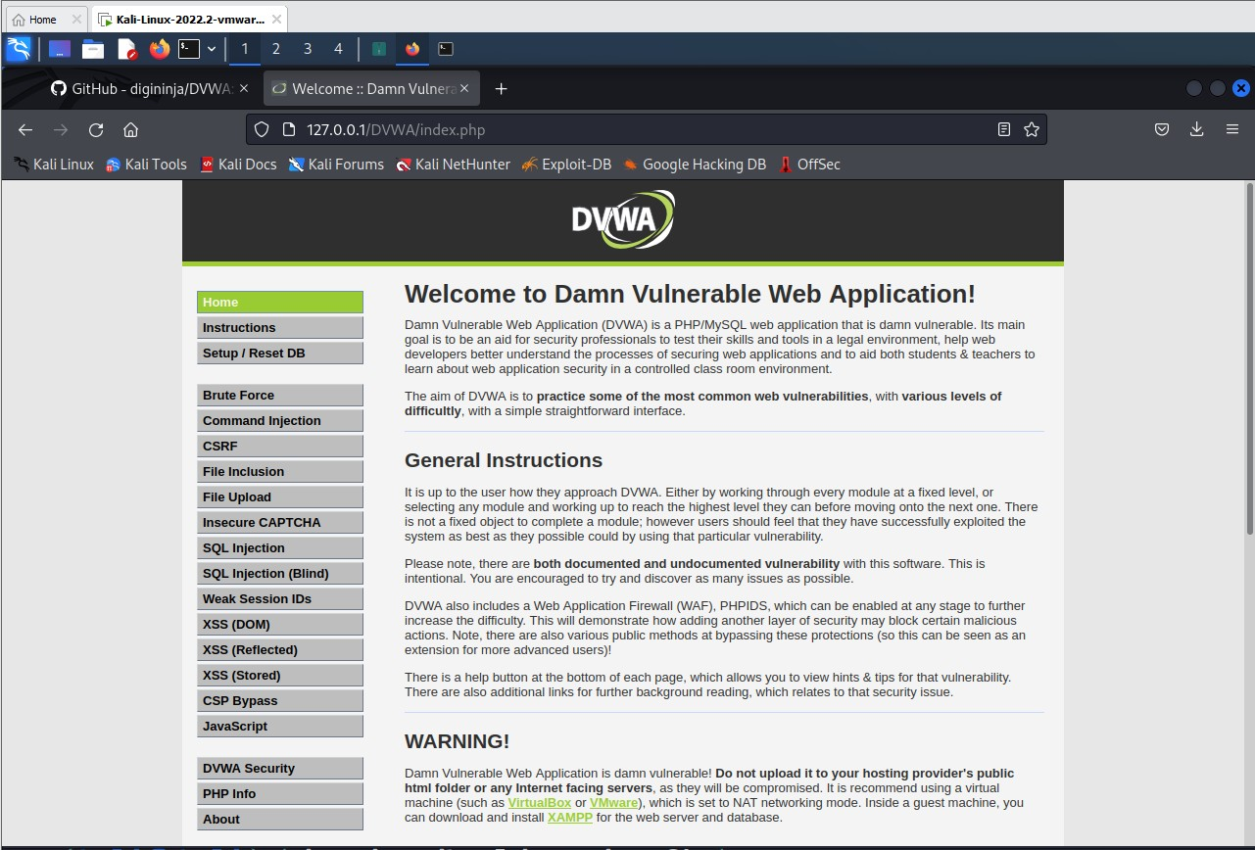

Goto DVWA security

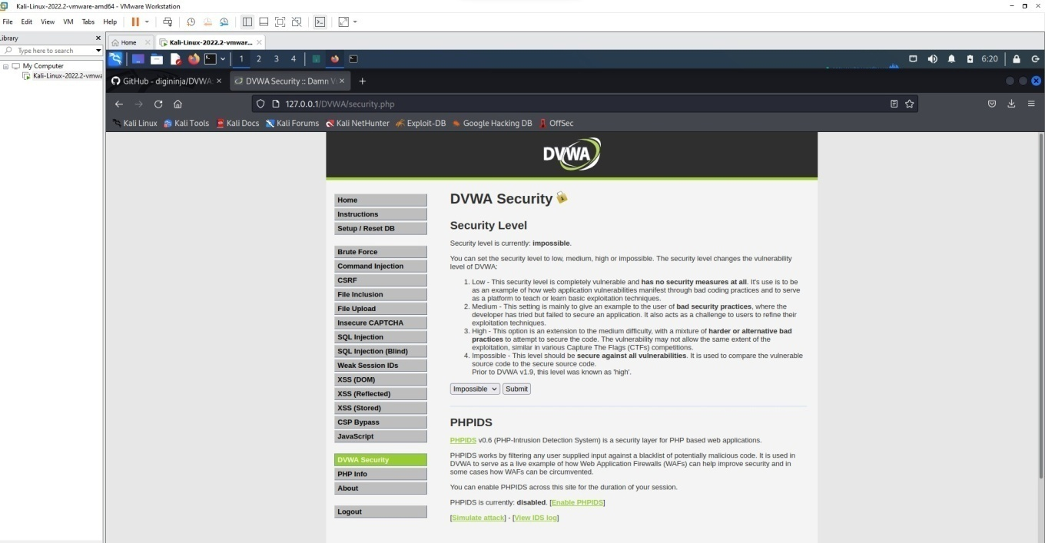

Click on impossible
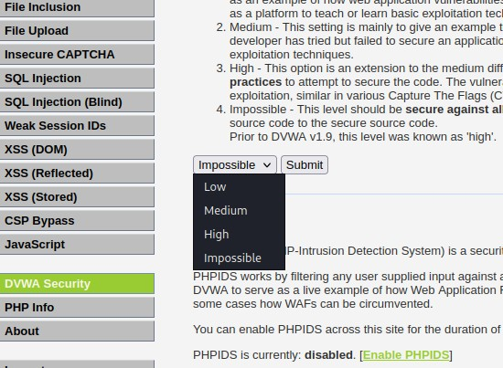

set as LOW.

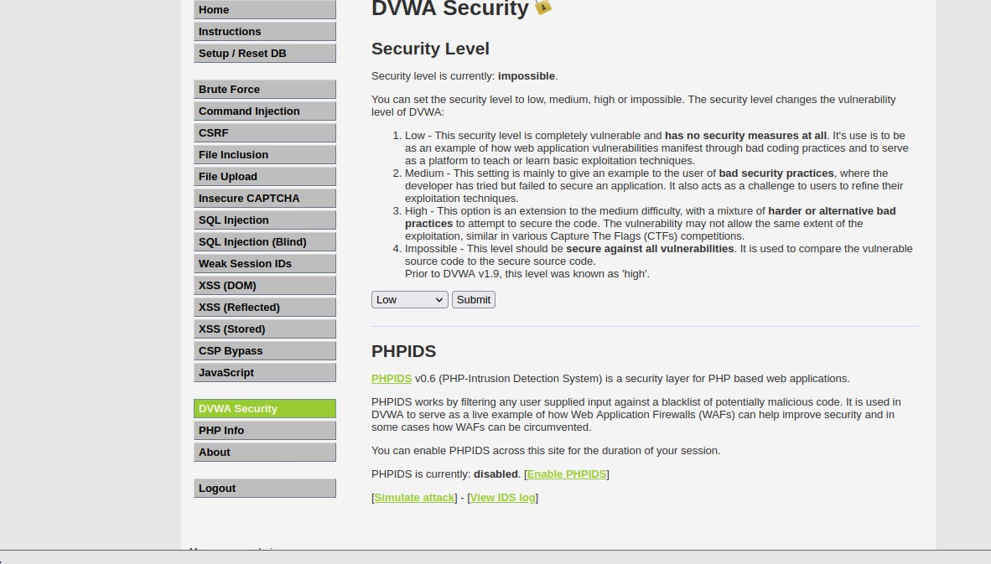

Click submit. Attacking the system:
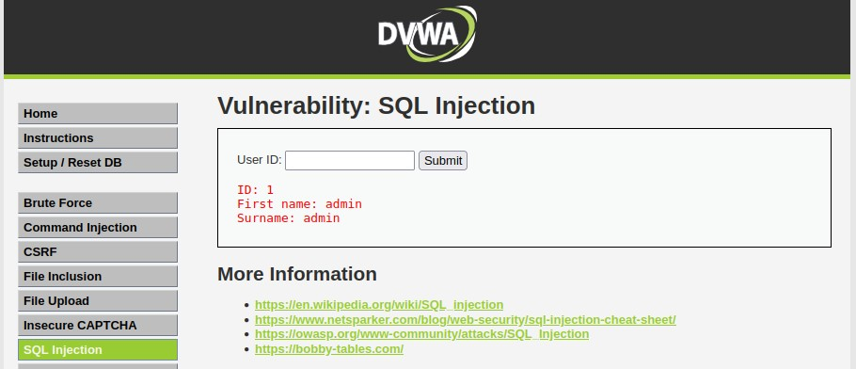
- SQLInjection: Enter 1 and Click submit
Enter 2 and Click submit

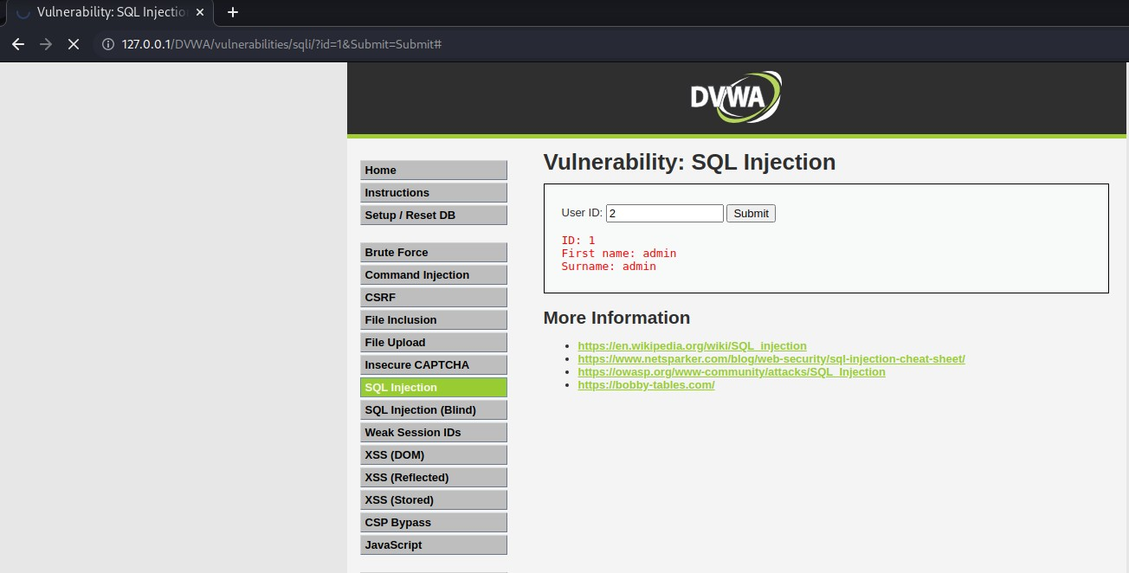

Enter %’ or ‘1’=’1
It displays all the information.
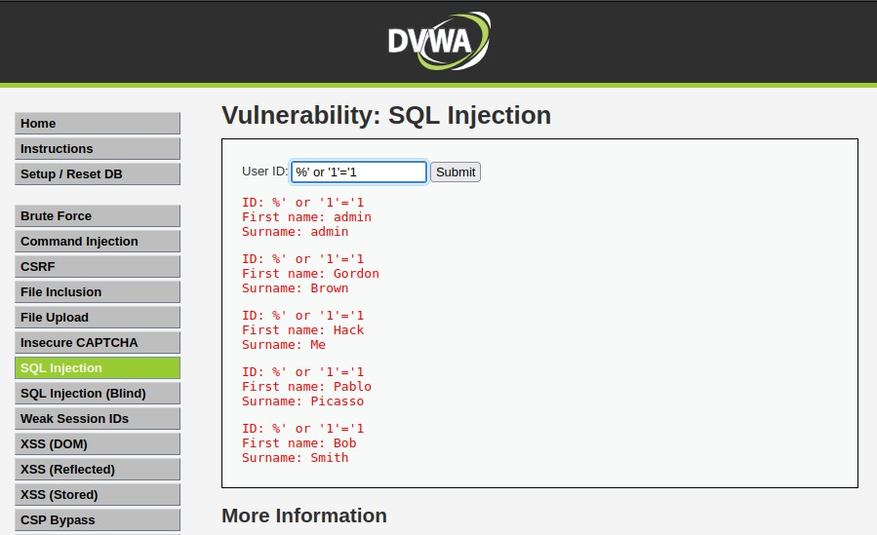
Result:
Thus the DVWA website setup and sql injection attack completed successfully

Experiment 4: Examination of a website to test the vulnerability of attacks. – XSS & CSRF & Command line injection attack.
— Command Injection Attack—

sudo service apache2 start
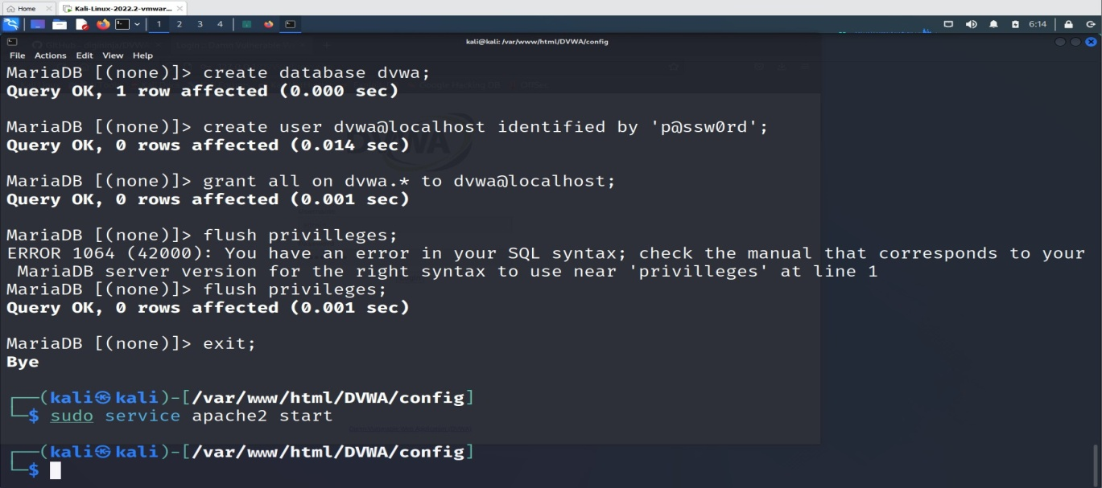

goto browser and give http://localhost/DVWA or http://127.0.0.1/DVWA/login.php
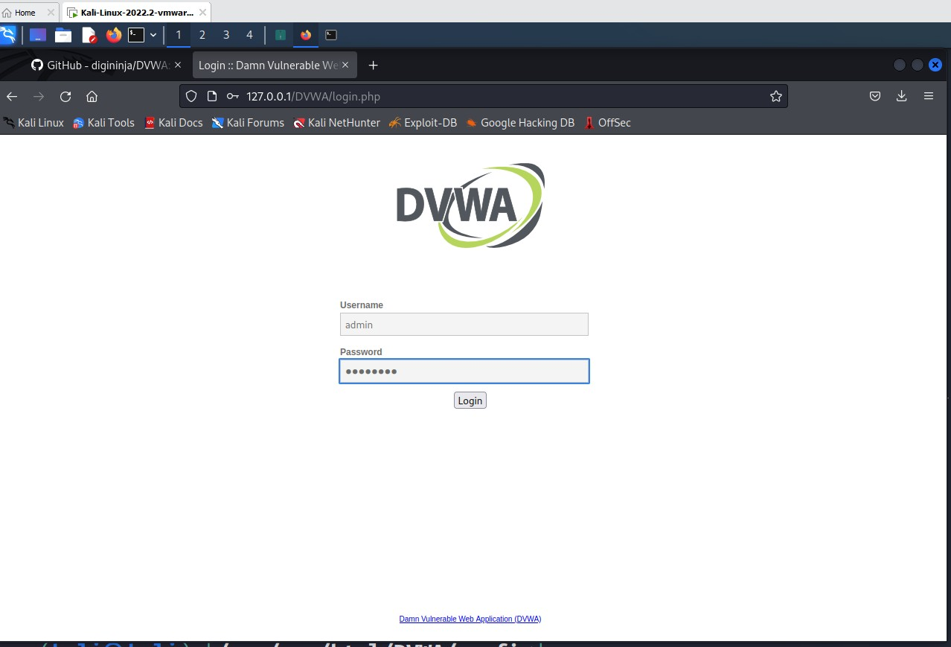

username: admin password: password

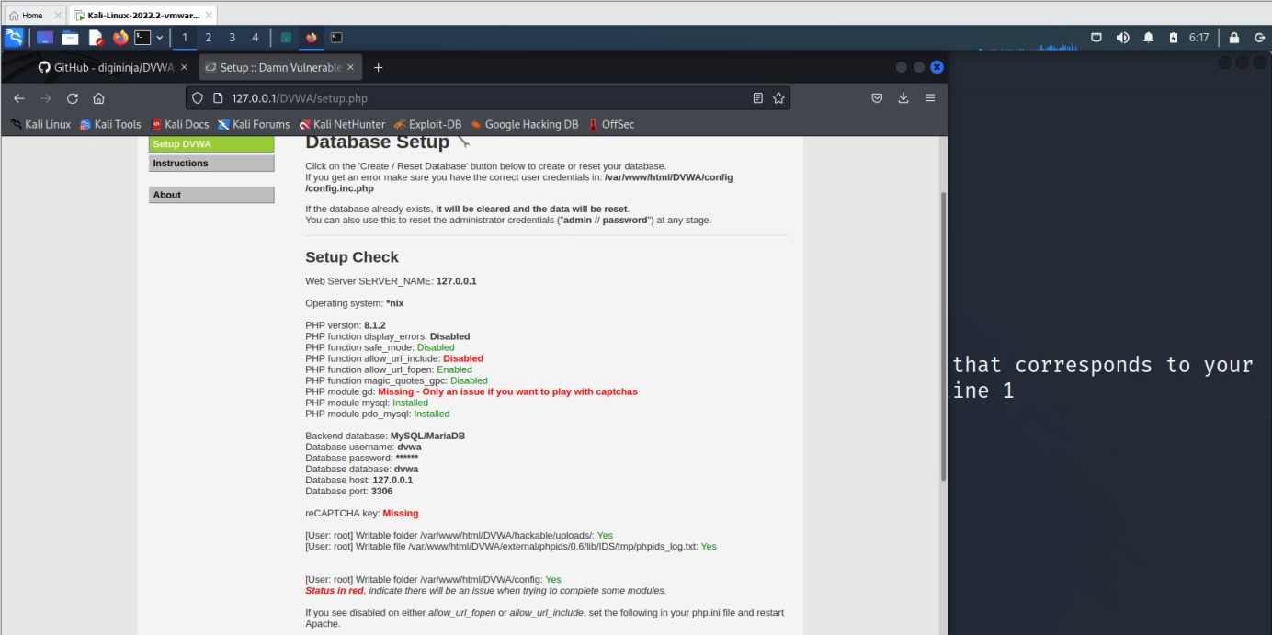

click create database
we get http://127.0.0.1/DVWA/index.php

Goto DVWA security

Click on impossible

Set as LOW and click Submit.

Enter IP address.
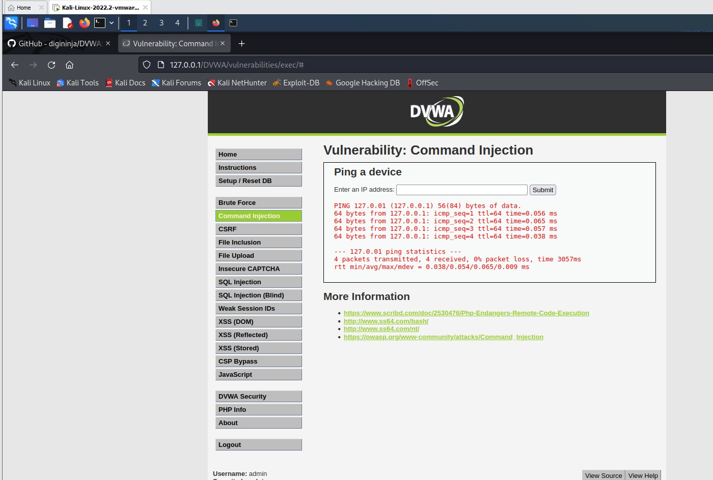

multiple commands using pipe or ; 127.0.0.1;ls

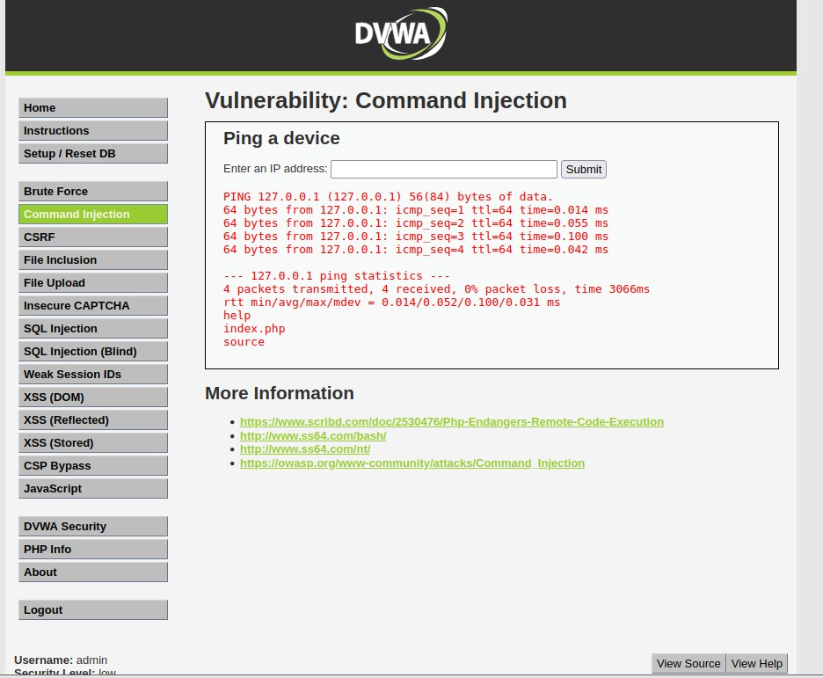

127.0.0.1;ls ../
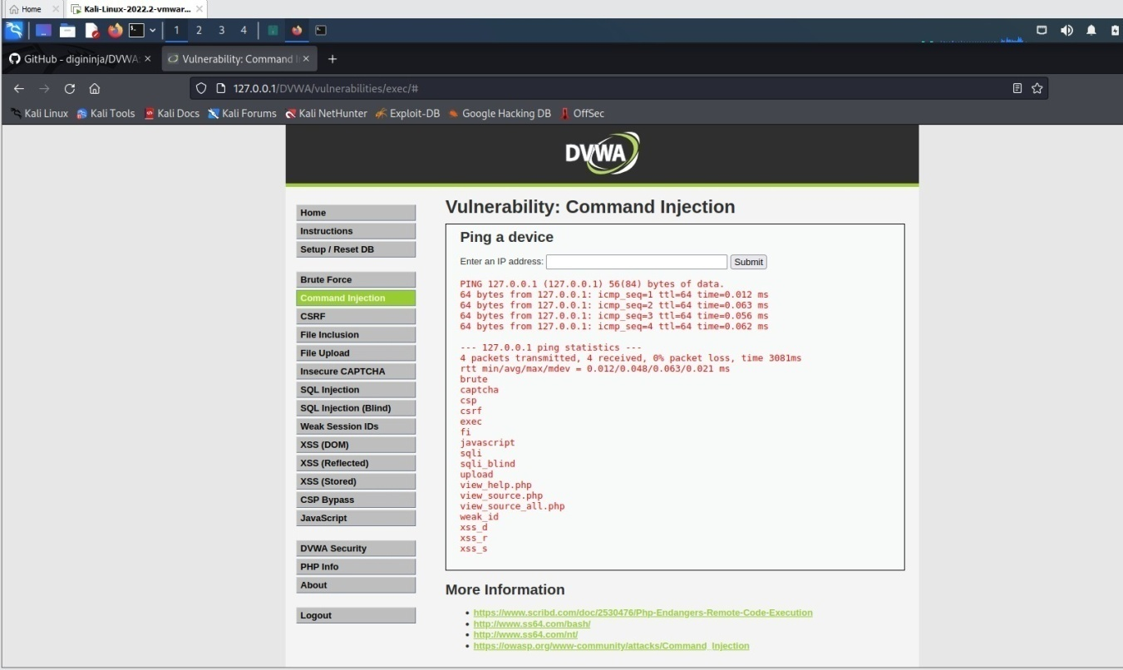
;cat ../view_source.php
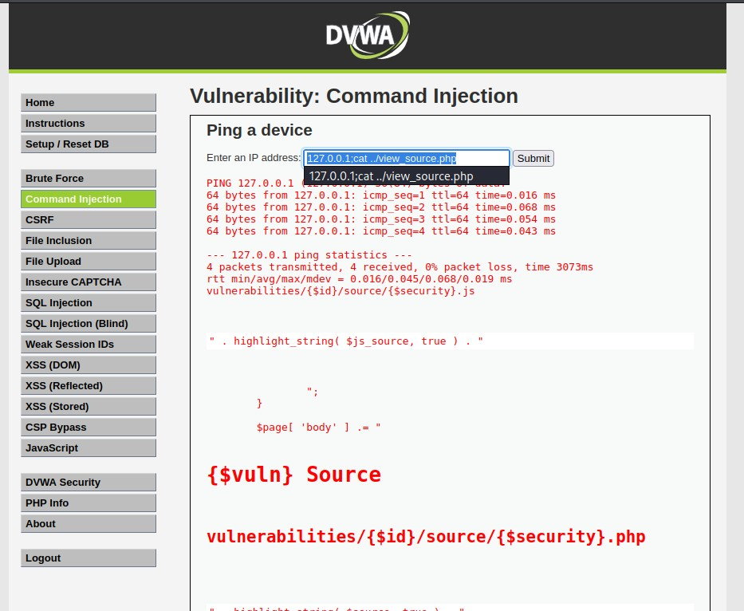

Use &&net user
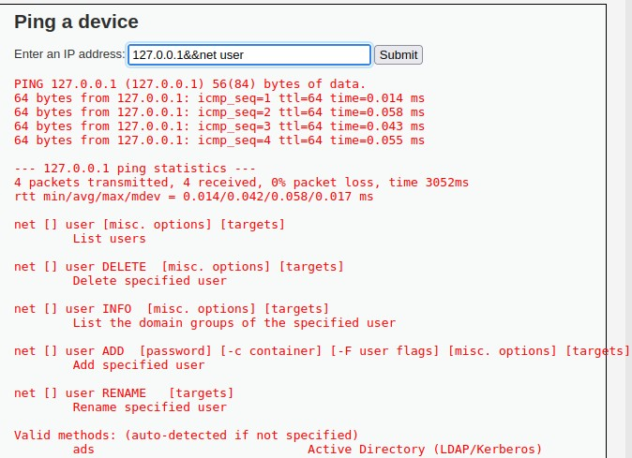

Use &net user
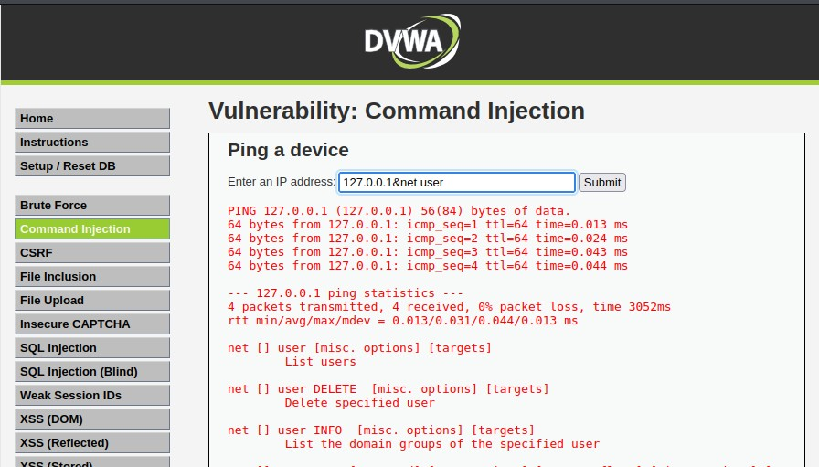

—------------------------------------------------XSS Attack------------------------------------------------------------

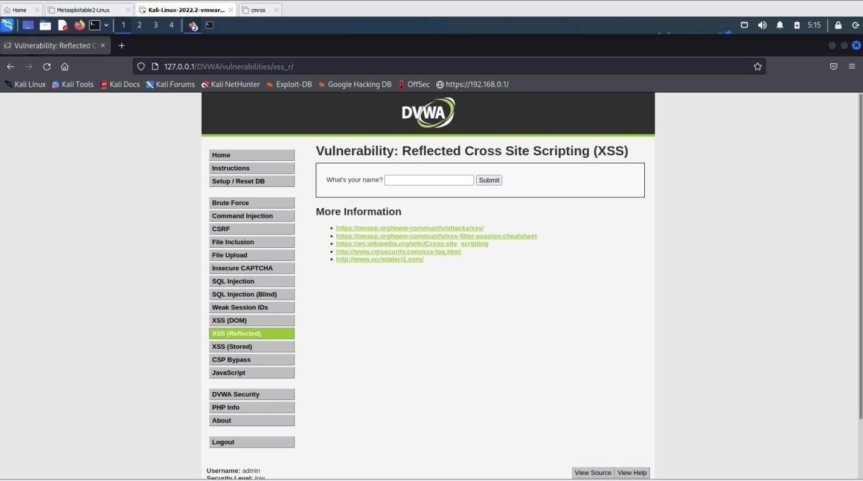
Click XSS Reflection
Enter any name in the text box and click submit.
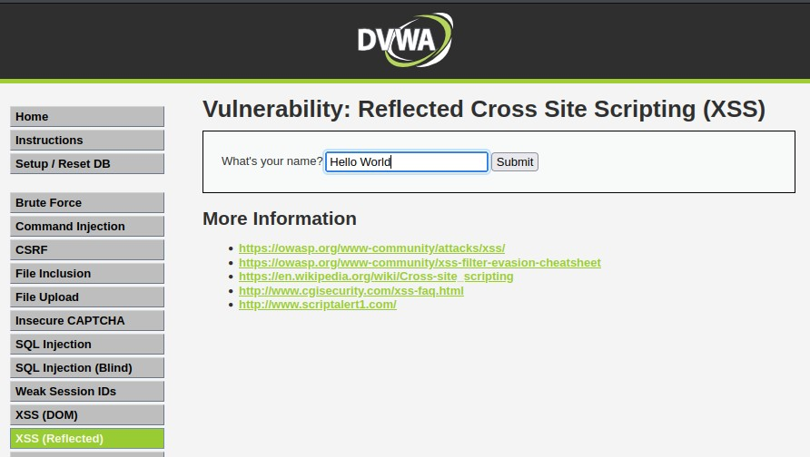
It displays as

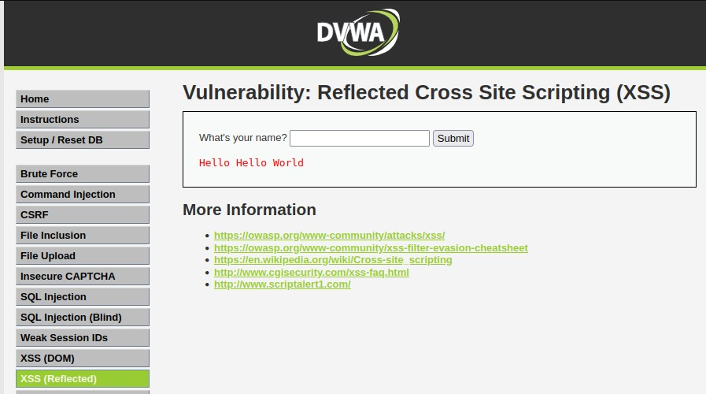
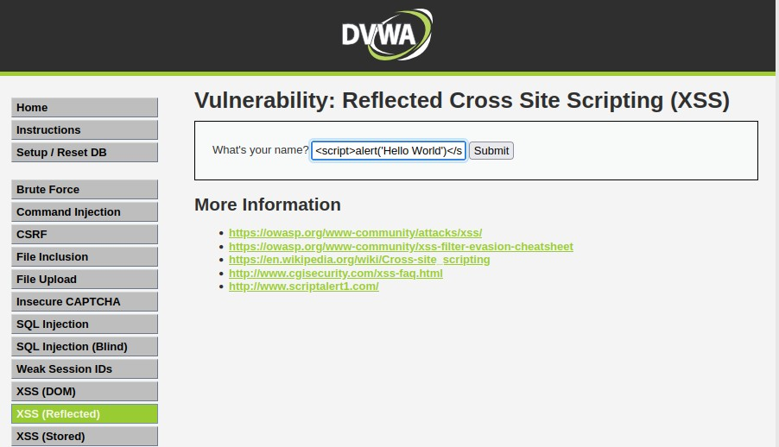
Now instead of any text let’s try some script text.

Ex: <script>alert('Hello World')</script>
It displays an alert as shown below

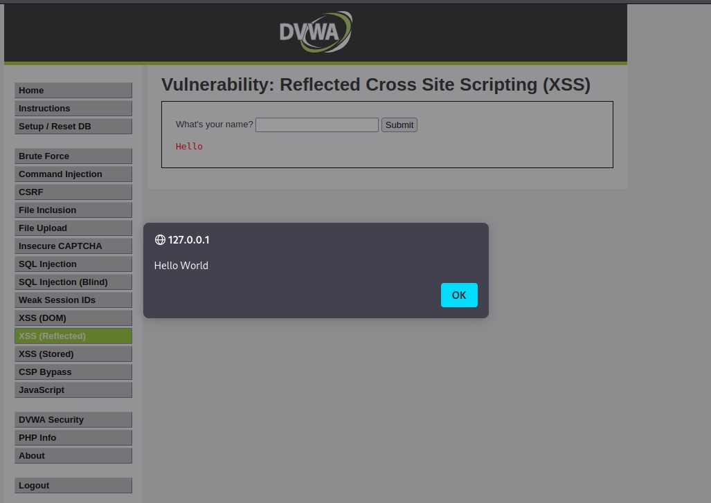

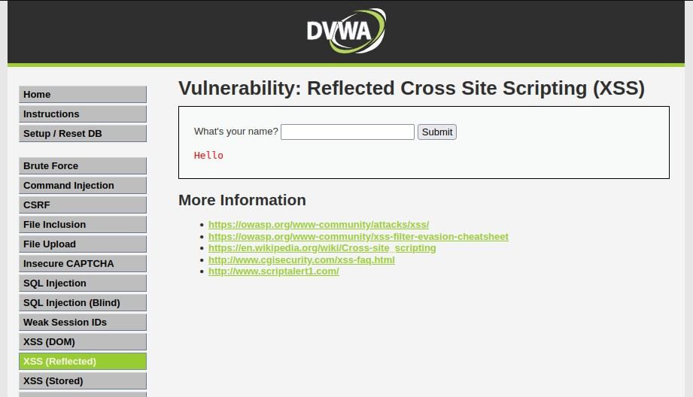
Click Ok

—-------------------------------------------------CSRF ATTACK—---------------------------------------------------
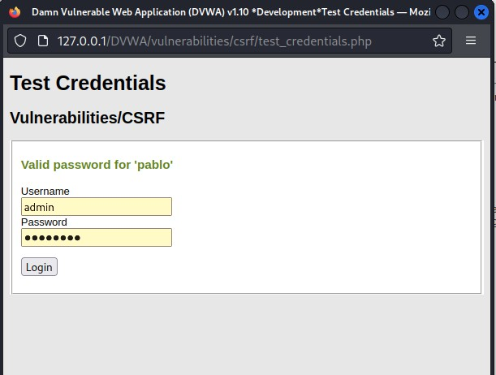

open burpsuite

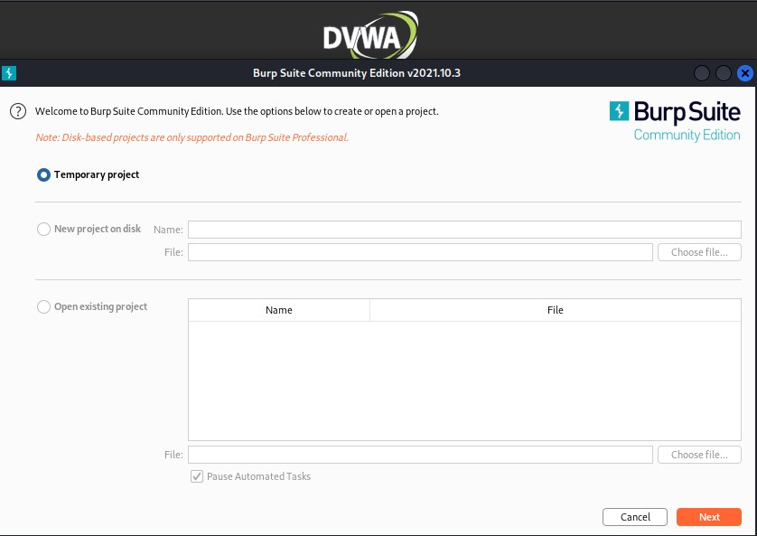

click start burp suite
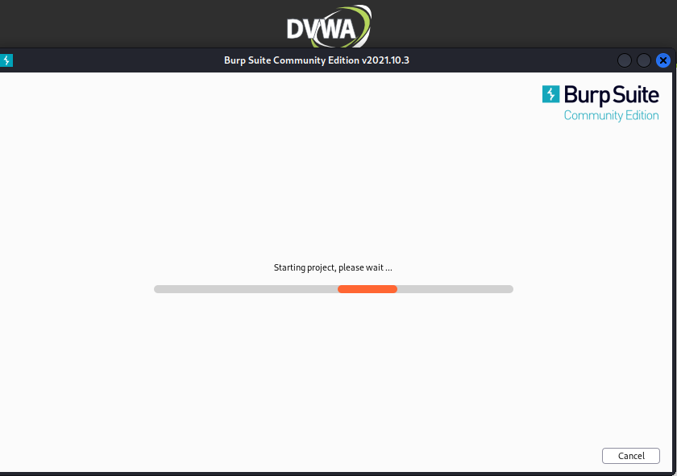

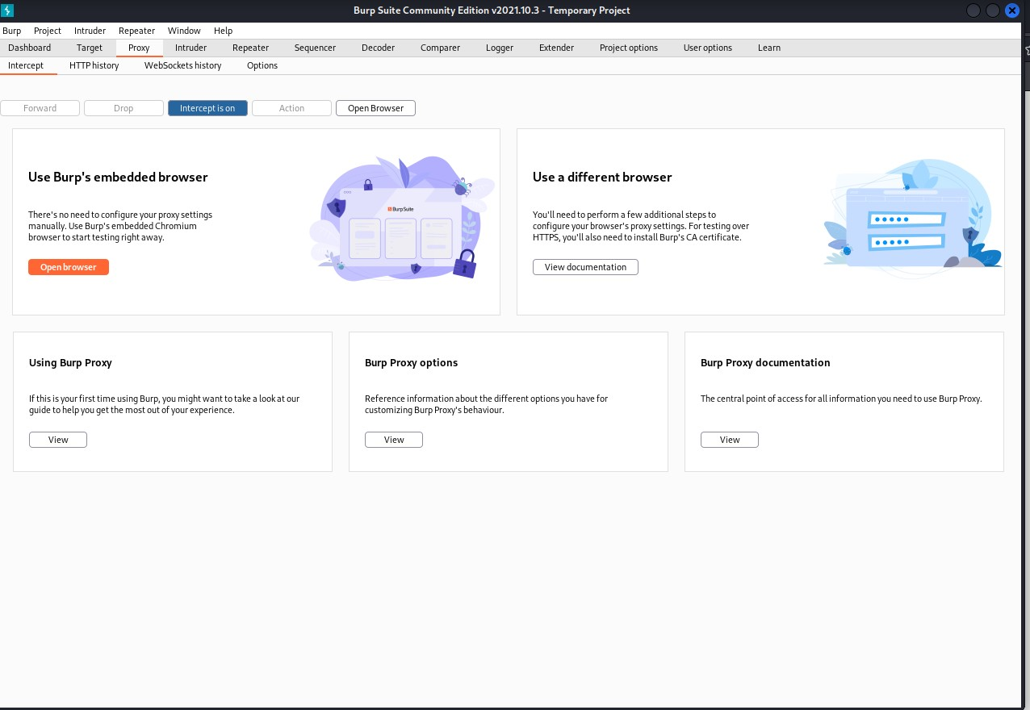

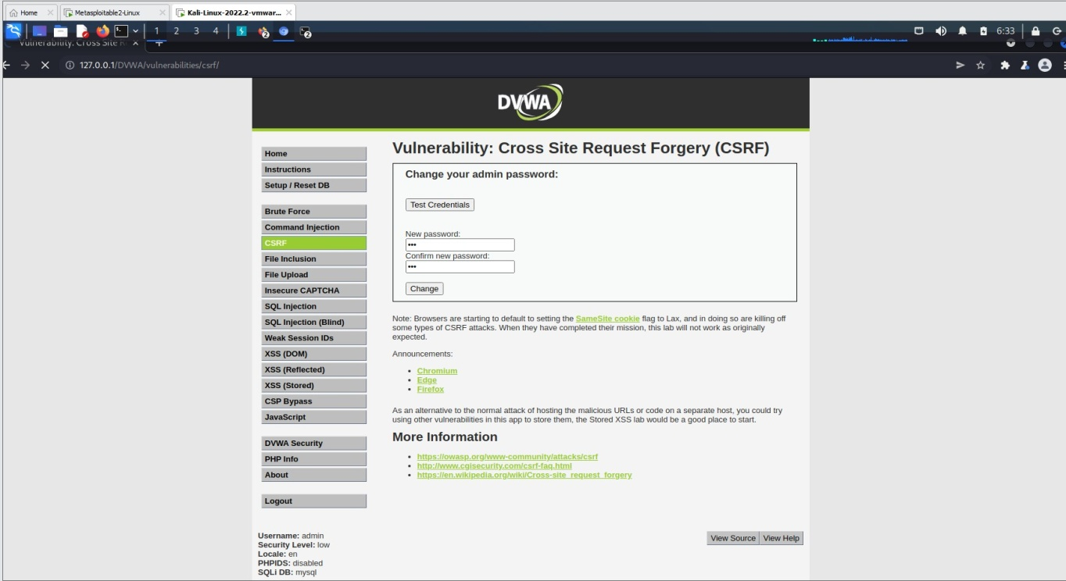
open browser search for

DVWA
http://127.0.0.1/DVWA/vulnerabilities/csrf/?password_new=new&password_conf=new&Change=Chang e
login after inception is on
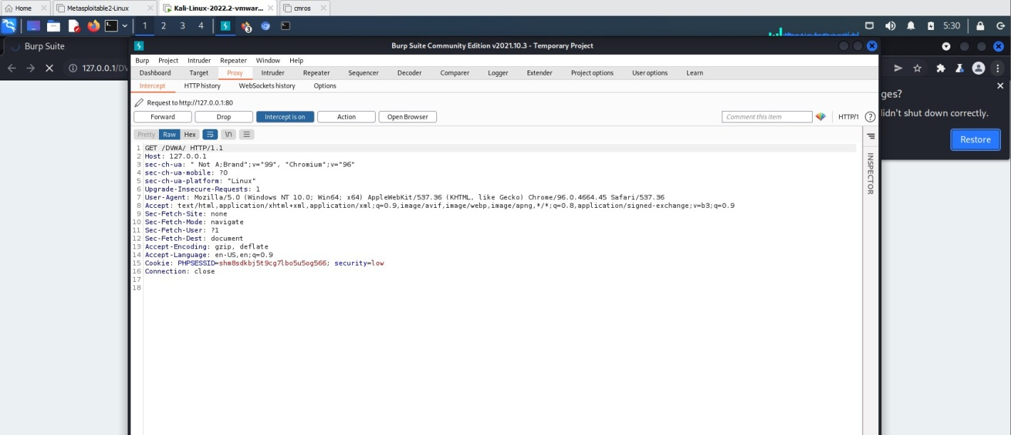
Go to browser using burp suite and

Result:
Thus the Command injection, XSS and CSRF attack completed successfully.

